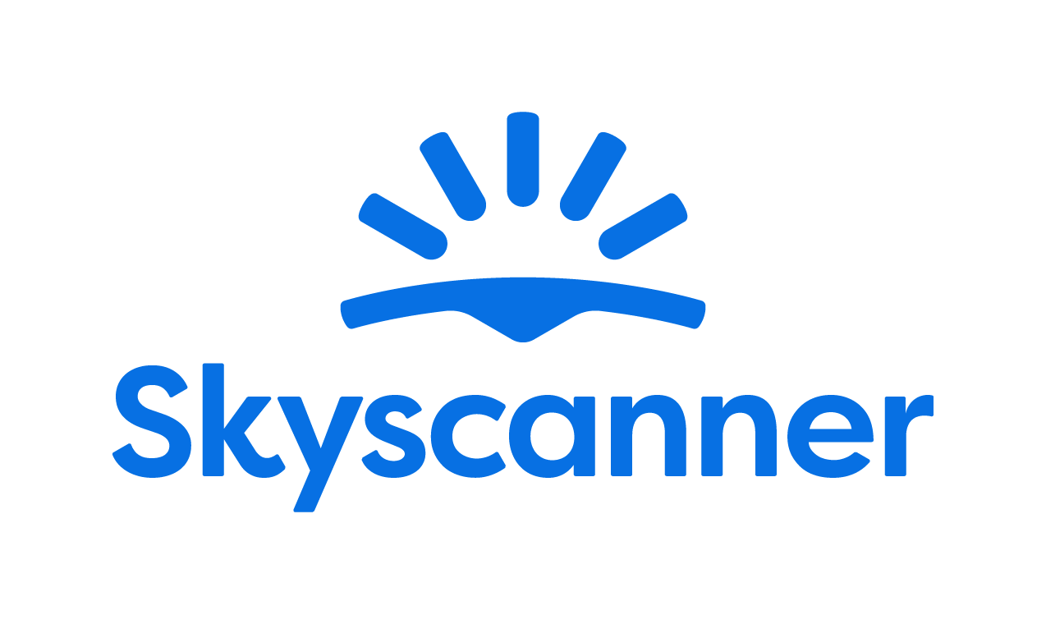

Localisation Style Guide

How to write and translate for Skyscanner in Italian

1. Our Tone of Voice 3
1.1 Playful 3
1.2 Geeky 4
1.3 Helpful 5
1.4 Using the tone of voice in localisation 6
2. General writing and translation guidelines 7
2.1 URL requirements 7
2.2 Placeholders, variables and tags 7
2.3 Inclusive language 8
3. Language-specific translation guidelines
8
3.1. Emphasis and intensifiers 9
3.2. References 9
3.3. Capitalisation and titles 10
3.4. Call to actions 10
3.5. Glossary terms and product names 10
3.6. Date format 11
3.7. The use of anglicisms 11
3.8. Abbreviations and acronyms 11
3.9. Addressing our users – Formality and T/V policy 11
3.10. Linguistic sequence 12
3.10.1. Transliteration 12
3.10.2. Geo-terms 12
3.10.3. Airport names 12
4. Cultural sensitivity 13
4.1. Emojis and symbols 13
4.2. Imagery 13
5. Translation guidelines per content type 13
5.1. User Interface (UI) 13
5.2. Marketing 14
5.3. SEO 14
5.4. Google Ads 14
5.5. App store 15
5.6. Editorial and blog posts 15
5.7. Emails and push notifications 15
5.8. Legal, Policies, Terms and conditions 15
6. Other Skyscanner-specific guidelines 16
6.1. Use of Skyscanner brand 16
6.2. Feature naming 16
6.3. The use of “Best” 17
6.4. The use of “Discount” 18
6.5. Translating sustainability-related content 18
6.6. Accessibility guidelines 19
7. Useful resources and links 19

Our Tone of Voice

Skyscanner sounds like a Geeky Travel Pal. This means that:
- Our tone is playful
- Our energy is geeky
- Our message is helpful

Do | Don’t
Con Skyscanner puoi confrontare centinaia di opzioni in pochi clic e scoprire i giorni in cui volare costa meno. ✈️ | Non serve essere degli esperti di prenotazioni per trovare voli low cost! ✈️

Our brand promise is to be a helpful, honest travel ally. Our tone of voice should always support this:
- We give clear, useful information so travellers feel savvy.
- We are fair and transparent, so travellers feel confident and secure.
- We lead with empathy, so travellers feel valued and understood.
When localising, keep the same personality, but adapt expressions so they feel natural in your language and culture.
Example:
Sappiamo quanto può essere stressante scegliere un volo. Per questo ti mostriamo tutte le opzioni in modo chiaro: prezzi, orari, durata e compagnie.
In questo modo, puoi confrontare facilmente e prendere la decisione giusta per il tuo viaggio.
E se hai dubbi, siamo pronti ad assisterti: il tuo viaggio è importante per noi.

1.1 Playful
Our tone is playful. We write with a light, natural energy. Playfulness helps us feel human and builds trust – but it must never reduce clarity.
What playful means for us:
- A conversational tone, as if talking to a friend.
- A rhythm that feels lively, not flat or robotic.
- Turning travel frustrations into simple tips and “travel hacks”.
We’d say:
Do | Don’t
Gli utenti possono ora consultare diverse tariffe di voli in maniera più efficiente. | Finalmente puoi confrontare i voli in un attimo, senza impazzire tra mille schede aperte.

Avoid
- “Fake-smart” corporate or management speak.
- Overly formal or stiff phrases.
- Trying too hard to be “LOL-funny”.

1.2 Geeky
Our energy is geeky: we love data, details and patterns – and we explain them in a human way.
What geeky means for us:
- We sound excited to share what we’ve learned.
- We show our travel expertise and curiosity.
- We break down complex information into simple steps.
Keep the tone enthusiastic but controlled. It should feel like a knowledgeable friend, not a lecture.
We’d say:
Do | Don’t
Conosciamo i limiti di peso di 137 compagnie, così puoi superare il check-in senza preoccupazioni. | Disponiamo delle informazioni relative ai limiti massimi di peso del bagaglio per la maggior parte delle principali compagnie aeree, in modo da evitare spese aggiuntive e disagi. Stiamo attenti a OGNI SINGOLO GRAMMO!

1.3 Helpful

Helpful is our foundation. If you must choose between playful, geeky and helpful, be helpful first.
Our writing should:
- Make complex travel information simple.
- Make confusing situations clear.
- Make overwhelming choices manageable.

Do | Don’t
Vuoi scoprire il giorno più economico per volare? Ti aiutiamo noi! | Se stai cercando di capire qual è il giorno più economico ma è tutto così confuso (troppi siti, troppe schede aperte!) tira un sospiro di sollievo. È proprio per questo che siamo qui!

How to write helpfully
1. Put travellers first
- Focus on what they need to know, not on us.
- Start with the benefit or instruction, then explain how we know.
- Ask nicely - to help the traveller take action, they’ll be more inclined if we’re polite and respect their time.
Do | Don’t
Ti proponiamo i migliori prezzi dei voli sondando migliaia di opzioni | Cerchiamo migliaia di opzioni di volo così potrai ottenere i migliori prezzi.

2. Be honest, upfront and take responsibility
When sharing bad news or apologising:
- Drop most of the playfulness.
- Always apologise if something is our fault. If it isn’t, show empathy instead.
- Be clear about what happened, what will happen next, and what we’re doing to fix it.
- Say sorry once, sincerely. Focus on solutions, not on how bad we feel.
- Avoid cold phrases like “We apologise for the inconvenience.

Do | Don’t
Purtroppo il tuo volo è stato cancellato dalla compagnia aerea. Sappiamo che può essere frustrante, ma non preoccuparti: faremo tutto il possibile per ottenere il rimborso. | Il tuo volo è stato cancellato dalla compagnia aerea. Ti faremo sapere se sarai rimborsato.

3. Keep it short and simple
- Use short sentences and simple structures.
- Remove unnecessary words and repetition.
- Where you can, opt for the “pose question then offer solution” format.
Do | Don’t
Hai bisogno di aiuto? Contatta il team dell’assistenza clienti | Mettiti in contatto con il nostro team dell’assistenza clienti nel caso in cui avessi bisogno di aiuto

1.4 Using the tone of voice in localisation
When translating or adapting content for Skyscanner:
- Keep the three qualities – playful, geeky, helpful – but express them in ways that fit your language and culture.
- Prioritise meaning and clarity over matching English phrasing.
- Replace wordplay (rhyme, alliteration, puns) with devices that work naturally in Italian – or skip them if needed.
- Keep the friendly, human, travel-loving personality in every sentence.
Your goal: in every market, travellers should read the text and think,
“This sounds like a smart, friendly travel pal who’s genuinely here to help.”

General writing and translation guidelines

URL requirements
When translating or creating URLs for Skyscanner, follow these technical rules to keep URLs consistent, readable and safe across all markets. These are very important, since not following the guidelines may result in whole pages breaking and being unavailable for the audience.

- No spaces - If you need to separate words, use a standard hyphen -.
Do | Don’t
volieconomici | voli economici
voli-economici

- All lowercase

Do | Don’t
voli-economici | Voli-economici

- No extended or special characters. Replace them with the basic Latin letter.
Do | Don’t
o, e, n, c | ö, è, ñ, ç

Placeholders, variables and tags
Placeholders, variables and tags are there to make the text dynamic (e.g. inserting a city, date or price) or to format it. They must not be translated, deleted or changed.

Always keep them exactly as in the source, placed in the correct order for your language, and make sure the sentence is still natural and grammatically correct. Make sure to insert spaces where needed before/after the tags to avoid words being glued together when the placeholders are populated.
When a text contains a location placeholder (<location>) that can vary between a city, region, or country, fixed prepositions like “a” or “in” cannot always be used in Italian.
Workaround: place the placeholder at the beginning or the end of the sentence followed by a colon, then complete the sentence with the translated text.
Example:
English: Enjoy your weekend in + <location>
Italian: <location>: goditi questo weekend / Goditi il weekend in questa destinazione: <location>
This approach ensures clarity, grammatical correctness, and flexibility for any type of location.
These workarounds can be useful in different cases.

Inclusive language
Our language should be inclusive, welcoming, and respectful to all travellers. When translating for Skyscanner, avoid stereotypes, unnecessary references to gender, family, age, ability, or background, and choose wording that includes as many people as possible. Always prefer neutral, precise terms over clichés or labels.
- Use gender-neutral language where possible.
- Do not assume who people travel with, how they look, or what they can do.
- Avoid jokes or idioms that rely on stereotypes about nationality, age, gender, religion, or any other group.
- Focus on travellers’ needs and situations, not on labels.

Do | Don’t
Perfetto per gruppi, coppie o famiglie. | Perfetto per le mamme, i papà e i loro bambini.
Ottima soluzione per chiunque non ami la confusione. | Ottima soluzione per persone anziane che non amano la confusione.
Alcune strade sono ripide e potrebbero essere scomode per i viaggiatori con mobilità ridotta. | Il quartiere non è adatto alle persone disabili.
I ristoranti della zona offrono diverse opzioni di pasti. | I ristoranti della zona offrono pasti per diete normali e speciali.

Language-specific translation guidelines
Punctuation

Punctuation should make reading easier and clarify relationships within and between sentences. Therefore it is extremely important and its presence (or absence) can dramatically change the meaning of a sentence.

- The use of semicolons is recommended only in particularly long and complex sentences that could easily be simplified.

- Never use more than one exclamation or question mark.

- Please replace hyphens with parentheses or commas. However, avoid using parentheses in the subject line of an email.

- For consistency, please use the double straight quotes (" ").

- Let’s put punctuation marks that are part of a dialogue or quote inside the quotation marks and the period always outside.

- Using the accent instead of the apostrophe or vice versa is a serious (but unfortunately common) mistake. Also, please use the straight apostrophe, not the curly one.

- Ellipsis usually indicates an intentional omission of words, hesitating speech, thoughts trailing off and it is mostly used in informal writing, push notifications, etc. However, please don’t overuse it. Note that if the ellipsis replaces something in the middle of a sentence, then you don’t need a capital letter afterwards. If it replaces the end of a sentence, then you need a capital letter afterwards.

- Ampersands are quite widespread in English. Please don’t use them unless when they are part of a company or brand name.

- Euphonic d is inserted between two vowels to facilitate pronunciation and sound. Please follow its most common usage and use it only between two identical vowels, i.e. ad Atene, ed ecco, etc.
Some exceptions include those phrases which are now widespread in our language when the absence of the “d” would be considered very unusual: ad esempio, ad eccezione di, etc.
Finally the use of “od” is rare in written Italian and would be definitely inappropriate in our context.

Emphasis and intensifiers
Sometimes we use formatting and wording to emphasise key information for it to be easy to spot, or as an intensifier for a part of the message.
As a rule of thumb, prefer simple formatting (bold or italics) for emphasis and avoid using ALL CAPS or too many exclamation marks, as they can feel like shouting or spammy marketing.

References
When you refer to other content (pages, features, sections, links), use clear, consistent names and, where relevant, the exact label used in the UI.
Do | Don’t
Clicca sul pulsante “Torna ai risultati” qui sotto e ti reindirizzeremo ai risultati di ricerca di Skyscanner. | Clicca sul pulsante TORNA AI RISULTATI qui sotto e ti reindirizzeremo ai risultati di ricerca di Skyscanner.

Capitalisation and titles
In Italian, titles, subtitles, and headers follow different conventions from English. A period must never be used at the end of a title or subtitle, as Italian typography does not require closing punctuation in these cases.
Additionally, the English-style capitalization—where every important word begins with a capital letter—should not be replicated in Italian. Only the first word of the title takes an initial capital letter, while the remaining words stay lowercase, except for proper nouns or official product names. Moreover note that in Italian, month names and days of the week are written with a lowercase except when they refer to specific events or dates: il Venerdì santo, il Primo Maggio.
Do | Don’t
Prenota ora | Prenota Ora
Programma il tuo prossimo viaggio con Skyscanner | Programma Il Tuo Prossimo Viaggio Con Skyscanner

Call to actions
A Call to Action (CTA) is a short prompt designed to encourage the reader to perform a specific action such as visiting a page, learning more about a model, or completing a purchase. In Italian, CTAs should generally use the imperative mood, which is direct, concise, and engaging. Common examples include “Scopri di più”, “Vai alla pagina”, “Richiedi maggiori informazioni”.
Use the active voice wherever possible. The active voice is usually clearer, and it sounds more like a direct conversation with our users.
Focus on what the user can do next, using clear verbs and simple structures. When adapting to each language, keep CTAs natural and action-oriented, in line with local expectations for apps and website.

Glossary terms and product names

Glossary terms and product feature names should follow a consistent capitalisation pattern across the product. Use sentence case for descriptive unless they are treated as branded names in your language.
Keep capitalisation the same in UI and running copy, and do not switch between different styles (for example, avoid mixing “Price Alerts” and “price alerts” without a clear rule).
Examples:
Scopri di più sulle nostre offerte.
Cerca ovunque a maggio.
Trova i viaggi adatti al tuo budget con la nostra funzione Cerca ovunque.
Imposta gli Avvisi di prezzo per questo volo.

Date format
Follow Italian conventions for dates and time: day/month/year and 24-hour format for technical specifications.
Example: “Production started on 15/09/2023 at 14:30”

The use of anglicisms
As we said, Skyscanner community includes people of all ages, and not everyone is familiar with English language therefore if an Italian translation exists and it’s widespread and generally accepted please avoid anglicisms.

Do | Don’t
Scopri le destinazioni che hai visitato in passato. | Scopri le location che hai visitato in passato.

Abbreviations and acronyms
Abbreviations and acronyms should be spelled out the first time they appear, followed by the short form in parentheses. From then on, the abbreviation or acronym may be used, provided it is commonly understood in Italian.
Certain Italian abbreviations require a final period, such as ecc., pag., cap. If a sentence ends with an abbreviation that already contains a period, do not add a second full stop; the abbreviation’s period also serves as the sentence-ending punctuation.

Addressing our users – Formality and T/V policy

When translating the website and its various pages, please use the informal “tu” in Italian. This should be applied to all direct communication with users to maintain a consistent, friendly, and approachable tone of voice. This should be informal yet respectful: avoid bureaucratic or overly formal language. Prioritize clear, direct, and natural phrasing that feels human and engaging.
This approach also applies to messages addressed to a broader audience (even those starting with “Hello everyone!”). The only exception is legal content such as terms, conditions, and policies, where a more impersonal construction is appropriate.

Do | Don’t
Ciao Andrea, ti contattiamo per informarti… | Gentile Andrea, La contattiamo in seguito a…

Linguistic sequence

Transliteration
Follow common local usage and official standards when transliterating place names, stations, and key travel terms. Be consistent within the language: don’t mix different transliteration systems in the same text. Do not invent new spellings or “localise” brand names that are normally kept in Latin script. If there is an established local exonym (well-known local version of a place name), use that; otherwise use the standard transliteration.

Geo-terms
Use the official or most widely used local names for countries, cities, regions and airports, and keep them consistent across all content. Avoid outdated, politically sensitive or rarely used forms, and don’t over-translate when travellers expect the original name (for example in airport names or well-known landmarks).
We follow the spelling and naming used on Google Maps to ensure consistency across the site.

Airport names
When translating airport names, refer to the official sources to make sure the name is correct.
Never add the word “airport” when translating an airport name to avoid duplication; it’s usually used to populate placeholders in a running copy, and the term “airport” is added to the copy when needed.
Example:
Fly from @@airport-name@@ Airport
Do | Don’t
Paris Charles de Gaulle | Aeroporto Paris Charles de Gaulle

Cultural sensitivity

Emojis and symbols

- The only case in which we use emojis is when they are already present in the source.
- Make sure they are universally understood and appropriate in your market.
- Avoid replacing key words with emojis, and never use emojis in legal, policy or serious problem/incident messages.

When possible, replace any emojis or symbols present in the source copy if they are culturally inappropriate or the meaning is unclear in your market. When not possible/editable, flag the inappropriate content to Skyscanner and suggest a more suitable equivalent.

Imagery

Flag any imagery or references you encounter on Skyscanner product and other materials that could be seen as culturally inappropriate in your market (clothing, appearances, gestures, landmarks, food, family roles…)

Translation guidelines per content type

User Interface (UI)

- Be short, clear and action-focused. Prioritise clarity over playfulness.
- One idea per string; avoid ambiguity and extra words.
- Use the same wording consistently across product (e.g. always “Price Alerts”, not sometimes “Price Watch”).
Do | Don’t
Mostra i voli / Consulta le offerte | Diamo un’occhiata ad alcuni fantastici voli perfetti per te!
Viaggio salvato | Abbiamo completato con successo il salvataggio del tuo viaggio
Si è verificato un problema. Riprova. | Ops, qualcosa non ha funzionato per una misteriosa ragione…

Marketing
There is more room for creativity for Marketing content – we want the copy to sound natural, fluid and inspirational. Avoid sticking too close to the source text and make sure the translation feels like it has been created in Italian originally.
- Use the playful, geeky, helpful Skyscanner voice, but keep promises realistic and compliant
- Focus on traveller benefits: saving time, money, effort, or discovering new places.

Do | Don’t
Esplora New York spendendo meno. Confronta i voli in pochi clic. | Prenota ora i migliori voli per New York.
Trova idee per la tua prossima vacanza al mare. | Preparati alle migliori spiagge del mondo con i viaggi più convenienti del web.

SEO
- Prioritise natural language, not keyword stuffing.
- Write the way travellers actually search and think, while keeping our tone.
- Use clear, descriptive headings and titles.
- Keep meta titles and descriptions concise and helpful.

Do | Don’t
Cerca e confronta i voli per Tokyo, filtra per compagnia aerea, durata e scali e tieni traccia dei prezzi. | Il posto giusto per trovare incredibili offerte di voli per Tokyo.

Google Ads
- Be very concise; use clear benefits and a direct call to action. There are usually strict character limits.
- Avoid clickbait and unprovable claims (no “#1”, “best”, “cheapest ever”).
- Avoid exclamation marks and other unnecessary punctuation.
- Use common search language that travellers would type.

Do | Don’t
Trova offerte per i voli per Londra | Trova i voli più convenienti. Garantito!

App store
- Highlight main benefits and features clearly (search, compare, track prices).
- Use simple, natural phrases that work well in screenshots and previews.
- Avoid superlatives and guarantees.

Do | Don’t
Confronta voli, hotel e autonoleggio in un unico posto. | L’unica app di viaggio di cui hai bisogno.

Editorial and blog posts
- Use a warmer, more descriptive tone, but keep it factual and practical.
- Balance inspiration with concrete tips (times to go, rough prices, how to get around).
- Adapt and localise content that isn’t relevant for your market

Emails and push notifications
- Keep subject lines short and clear, and body copy friendly, helpful and inspirational.
- Make it obvious what the traveller can do next (search, check a deal, manage a booking).
Do | Don’t
Le allerte di viaggio per Lisbona sono cambiate | Non crederai a questa offerta folle!!!!
I prezzi del volo Roma-Dublino si sono abbassati. Scopri le tariffe aggiornate per capire se è il momento giusto per prenotare. | Clicca ora o perderai per sempre questa occasione. Le offerte migliori che tu possa mai trovare sono arrivate.

Legal, Policies, Terms and conditions

- Prioritise accuracy, clarity and consistency over tone.
- Be precise and neutral; avoid jokes, idioms and emotional language.
- Do not add promises or interpretations that are not in the source text

Do | Don’t
Questi termini si applicano a tutte le ricerche e prenotazioni effettuate sulla nostra piattaforma. | Questi termini si applicano solitamente alla maggior parte delle ricerche e delle prenotazioni.
Non garantiamo la disponibilità o il prezzo di un volo fino alla conferma della prenotazione. | Non possiamo sempre garantire la disponibilità o il prezzo di un volo prima della conferma della prenotazione.

Other Skyscanner-specific guidelines

Use of Skyscanner brand
The name Skyscanner is a core part of our brand identity and must be treated consistently across all languages. It should remain recognisable, correctly spelled, and used in a way that feels natural to the local audience while still protecting the brand.
When a transliteration may be used:

- When it improves readability in running copy and aligns with local norms
- Never translate or adapt the meaning of the name (e.g. never translate “sky” or “scanner”).
- Do not add articles unless they are required in your language and sound natural.
- If in doubt, always use Skyscanner in English and flag questions to Skyscanner.

Feature naming

When localising feature names, focus on meaning and user clarity, not on literal translation. A good feature name should be:
- Short and easy to scan
- Clear about what the feature does
- Natural and familiar in your language
- Consistent with terminology used by other travel providers in your market
Avoid direct, word-for-word translations if they sound strange, misleading, or carry unintended meanings. Only use the English name if it is already widely known and expected in your market.
Before finalising a name, check:
- How similar features are named by local travel providers
- Whether the term is already standard or commonly understood by travellers
- Whether the name could be misinterpreted
Example:
The English term “Packages” may be misunderstood as “parcels” in some languages, while we refer to a new vertical offering package holidays including flights and a hotel.
A clearer, more natural option in your language could be “package holidays” or the local equivalent travellers recognise.

The use of “Best”

Be careful with the use of “best” and superlatives in general. We are unable to claim that we can find travellers the “best prices” and “best deals” as this is an objective claim versus our competition that we would not be able to substantiate.

We can, however, use “Best” when there is a clear disclaimer explaining how "best" is measured.

Example:
Do | Don’t
Questo è il miglior prezzo che abbiamo trovato sulla piattaforma, in base alle nostre ricerche approfondite. | Questo è il miglior prezzo per il volo.

For example, we can sort our flight results by “Best” results since we have a disclaimer clearly explaining how this is measured:

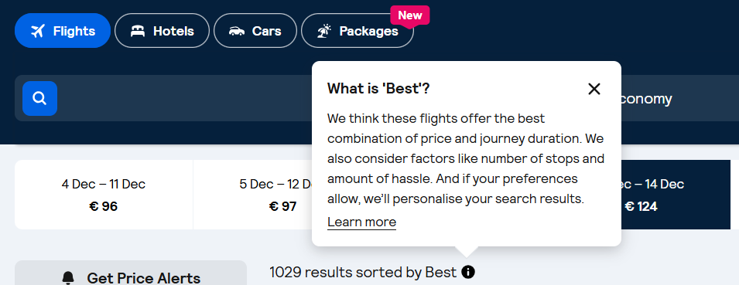

Generally, when the English copy says “best”, it’s safe to translate it the same way. When this is not the case, do not use “best” or other superlatives. Instead, use subjective claims such as “epic prices” or “amazing deals”.

The use of “Discount”

Skyscanner never offers discounts to users. Any discounts come from partners (for example Trip.com), not by Skyscanner.
For this and especially for legal reasons we can therefore never imply that “we offer” or “Skyscanner offers” a discount. This must be translated in a neutral way, i.e. “You are offered a discount”.

Never use the translation or equivalent of “discount” when the English source refers to a “deal” or “price drops” – these are not discounts but results of price fluctuation and it would be legally incorrect to refer to discounts.

Do | Don’t
Ti mostriamo i prezzi dei voli che sono diminuiti di almeno il 20%. | Ti mostriamo i prezzi dei voli che hanno uno sconto di almeno il 20%.

Translating sustainability-related content
When localising content about anything related to sustainability for Skyscanner, it’s essential to communicate responsibly and avoid greenwashing. Travel has an undeniable environmental impact, and our language must reflect this honestly and transparently. Use the following principles when translating or adapting sustainability-related content:
- Prefer comparatives over absolutes. Use relative statements such as “X is more sustainable than Y”, rather than implying that any option is fully sustainable.
- Avoid superlatives. Do not use expressions like “il volo più ecologico” or “la scelta più green”, as they can overstate environmental benefits.
- Use transparent and factual language. Base all claims on clear, measurable data.
- Steer clear of vague or unregulated terms. Avoid words like ‘naturale’, ‘green’, ‘non tossico’ and ‘rispettoso dell’ambiente’, unless the statement is supported by verifiable, standardised criteria.
- Do not make unsubstantiated claims. Only reference environmental performance when data is available. Never imply that a flight or travel option is “sostenibile,” “ecologica”, “green,” “pulita,” “rispettosa del pianeta”.
- Avoid reinforcing “green” imagery or symbolism. Be cautious with metaphors and word associations that might imply aviation is environmentally harmless. Overuse of green or nature-themed language can unintentionally suggest a level of sustainability that does not exist in commercial aviation today.
Do | Don’t
Il volo emette il 20% in meno di carbonio rispetto a un tipico volo per la stessa tratta | Questo è un volo ecologico
 | Questo è il volo più sostenibile

Accessibility guidelines

When writing for Skyscanner in Italian, content should be clear, inclusive, and easy to understand for all users. Use plain, natural Italian and avoid unnecessary jargon, complex sentence structures, or unexplained abbreviations. Prefer commonly used terms over anglicisms when an established Italian equivalent exists. Ensure that headings, link text, and calls to action are descriptive and meaningful when read out of context, as they may be accessed via screen readers. Emojis, symbols, and special characters should be used sparingly and only when they do not interfere with comprehension or assistive technologies.
Full guidelines available at this link.

Useful resources and links
Refer to authoritative linguistic resources, such as Accademia della Crusca and Treccani, as primary sources for correct grammar, spelling and usage.

